WEEK 3 – PROCESS SCHEDULING SIMULATOR

Project Report
1. Objective
To design and implement a CPU scheduling simulator in C that simulates different CPU scheduling algorithms and analyzes their performance.
The simulator accepts process details, displays Gantt charts, calculates scheduling metrics, and evaluates CPU utilization.

2. Input Specification
The CPU Scheduling Simulator takes process details as input and executes the selected CPU scheduling algorithm. These inputs are used to calculate Waiting Time (WT), Turnaround Time (TAT), Response Time (RT), and their averages.
1. Number of Processes (n):
Specifies the total number of processes to be scheduled.
2. Process ID (PID):
A unique identifier assigned to each process, such as P1, P2, P3, and P4.
3. Arrival Time (AT):
The time at which a process enters the ready queue.
4. Burst Time (BT):
The total CPU execution time required by a process.
5. Priority:
Indicates the priority of a process. A smaller number represents a higher priority.
6. Time Quantum:
The fixed time slice allocated to each process in the Round Robin algorithm.
7. Scheduling Algorithm:
The user selects one of the six implemented algorithms:
- FCFS (First Come First Serve)
- SJF (Shortest Job First – Non-preemptive)
- SRTF (Shortest Remaining Time First)
- Priority Scheduling (Non-preemptive)
- Priority Scheduling (Preemptive)
- Round Robin (RR)

3. Performance Metrics
1. Completion Time (CT):
The time when a process finishes execution.
2. Turnaround Time (TAT):
TAT = CT − AT
3. Waiting Time (WT):
WT = TAT − BT
4. Response Time (RT):
RT = First CPU Start Time − AT
5. Average Waiting Time:
Average WT = Total Waiting Time ÷ Number of Processes
6. Average Turnaround Time:
Average TAT = Total Turnaround Time ÷ Number of Processes
7. Average Response Time:
Average RT = Total Response Time ÷ Number of Processes
8. CPU Utilization:
CPU Utilization (%) = (CPU Busy Time ÷ Total Elapsed Time) × 100
CPU Busy Time = Total Elapsed Time − Total Idle Time
If the CPU is busy continuously from time 0 until all processes finish, CPU utilization is 100%. If idle intervals occur, include them in the calculation.

4. Test Case 1
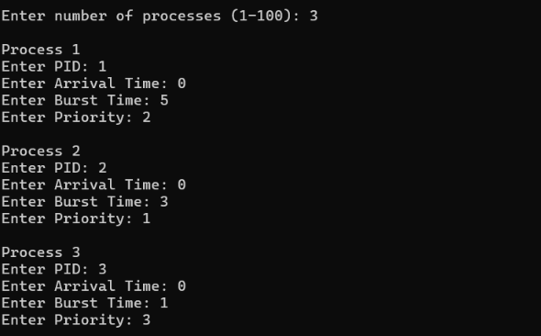

4.1 FCFS
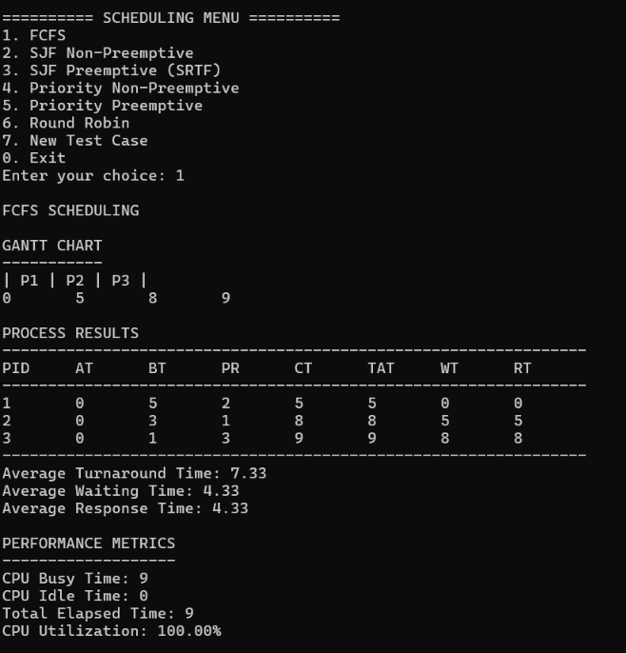
4.2 SJF Non-Preemptive
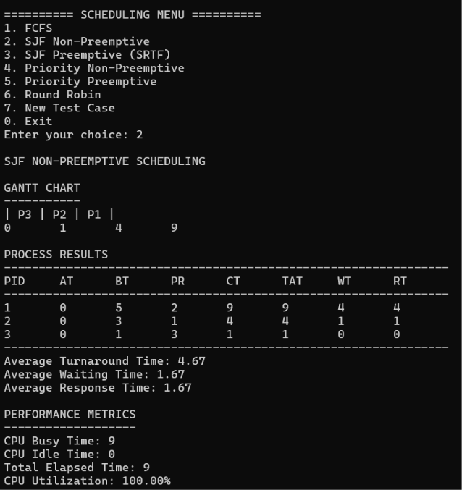

4.3 SJF Preemptive (SRTF)
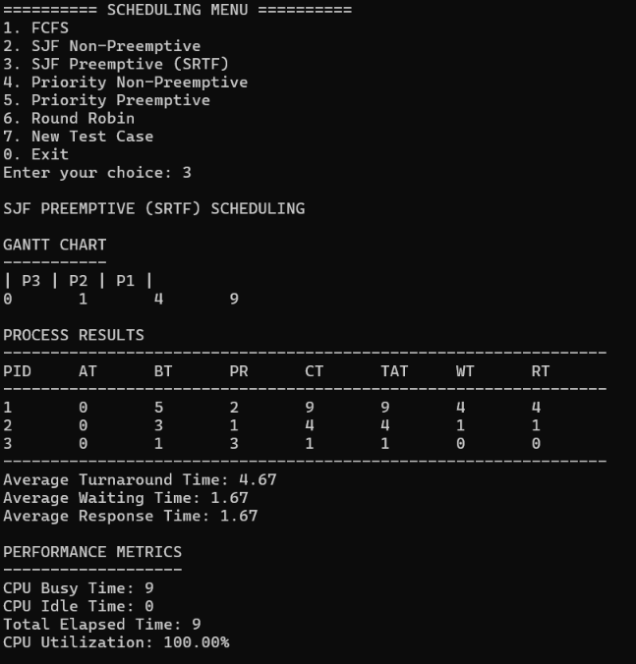

4.4 Priority Non-Preemptive
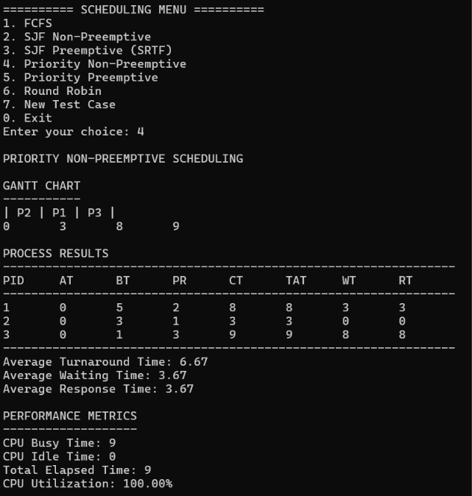

4.5 Priority Preemptive
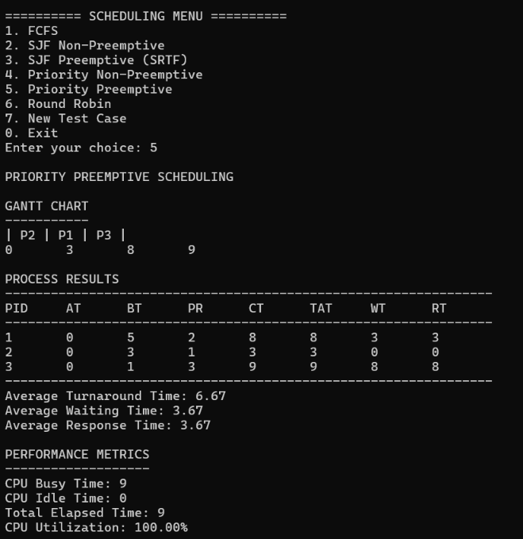

4.6 Round Robin
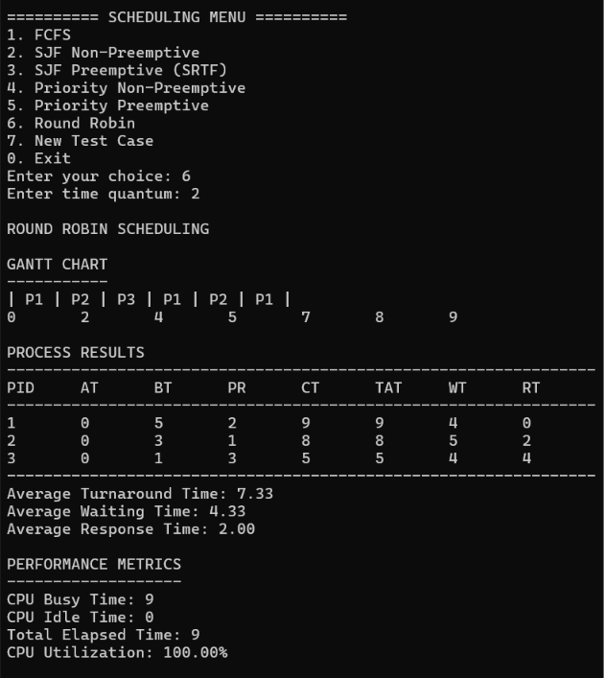

4.7 Compare All Algorithms
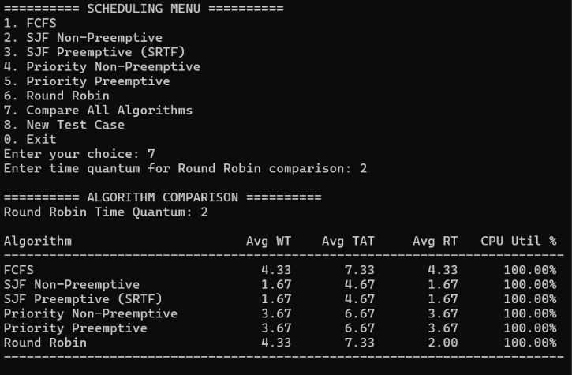

5. Test Case 2
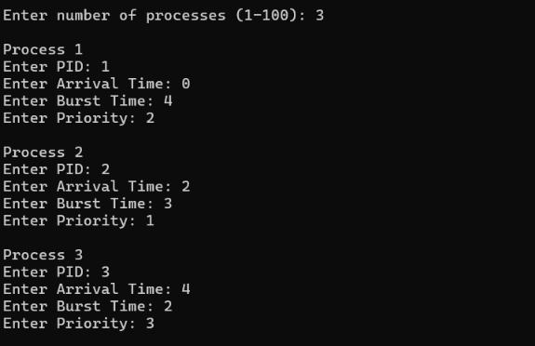
5.1 FCFS Scheduling
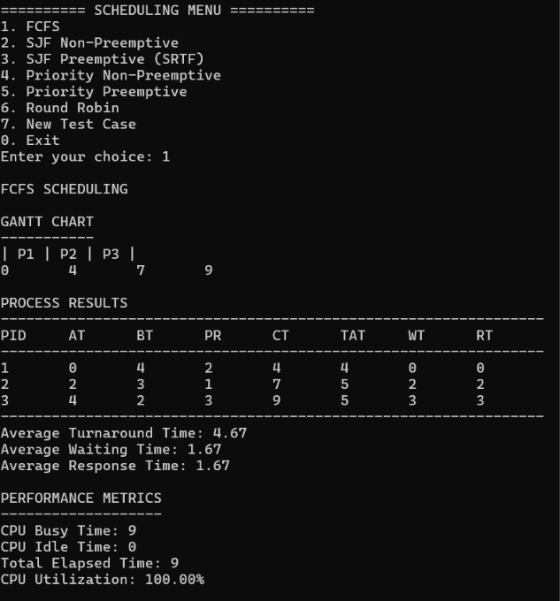

5.2 SJF Non-Preemptive Scheduling
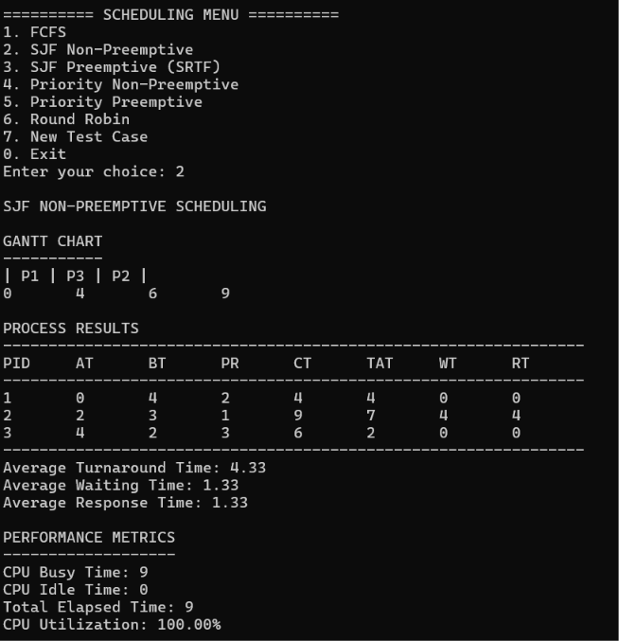

5.3 SJF Preemptive (SRTF) Scheduling
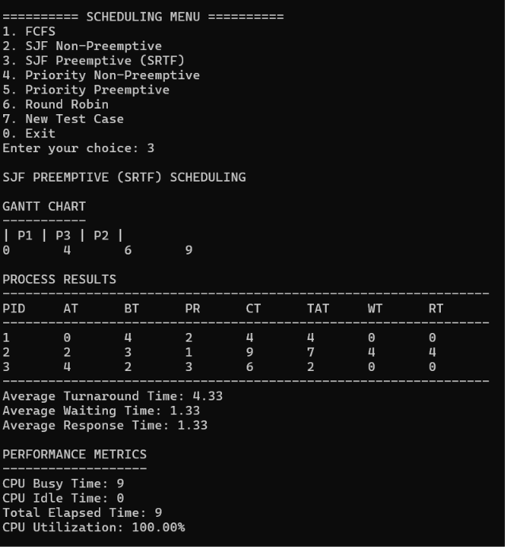

5.4 Priority Non-Preemptive Scheduling
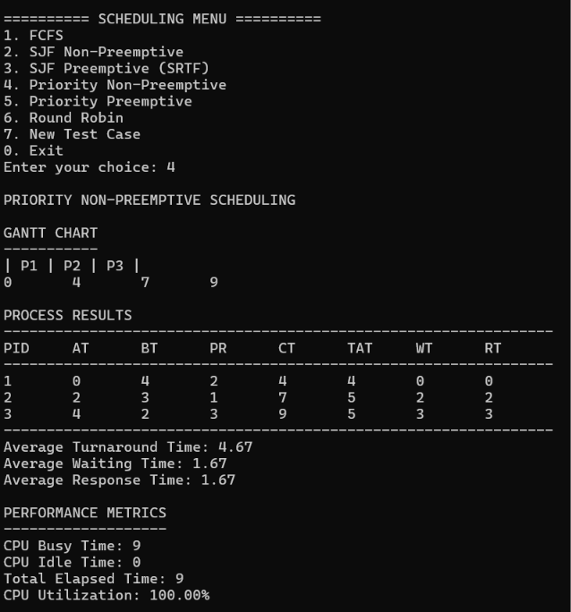

5.5 Priority Preemptive Scheduling
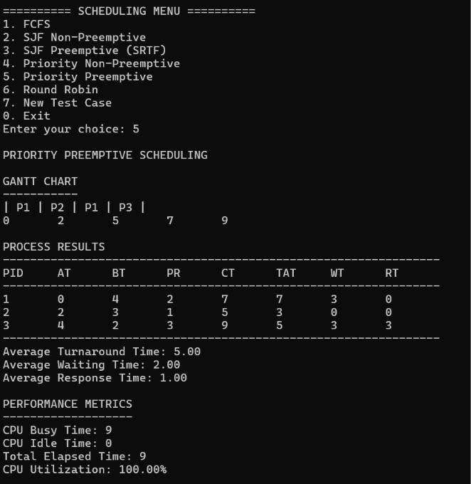

5.6 Round Robin Scheduling

5.7 Compare All Algorithms
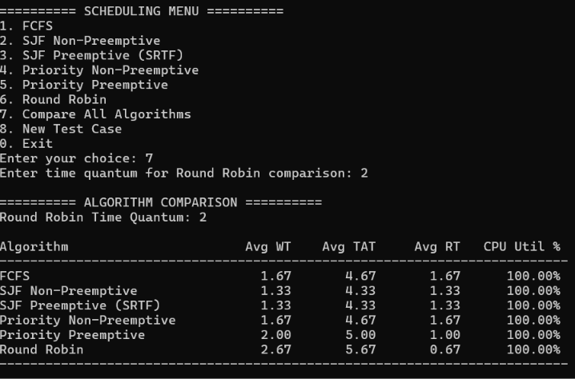

6. Test Case 3
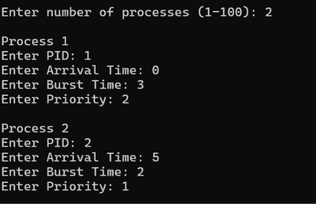

6.1 FCFS Scheduling
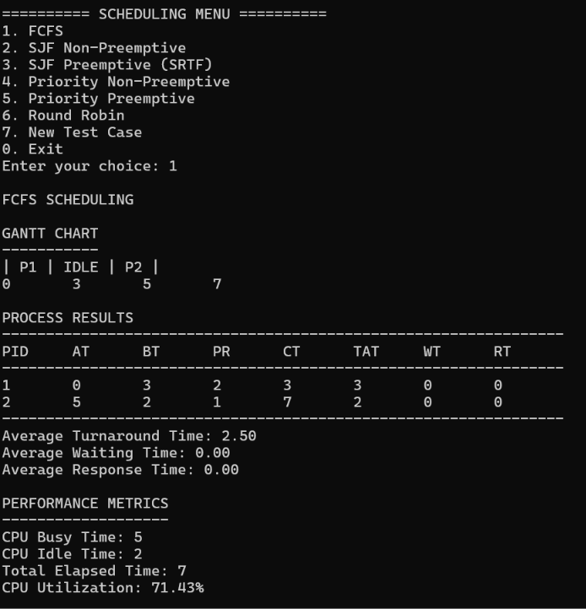

6.2 SJF Non-Preemptive Scheduling
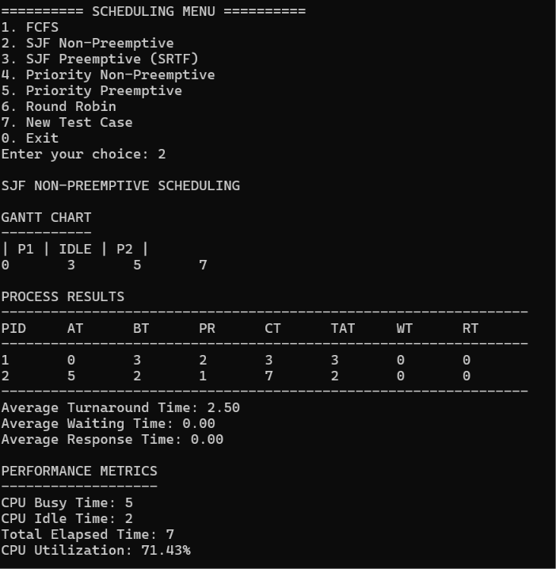

6.3 SJF Preemptive (SRTF) Scheduling
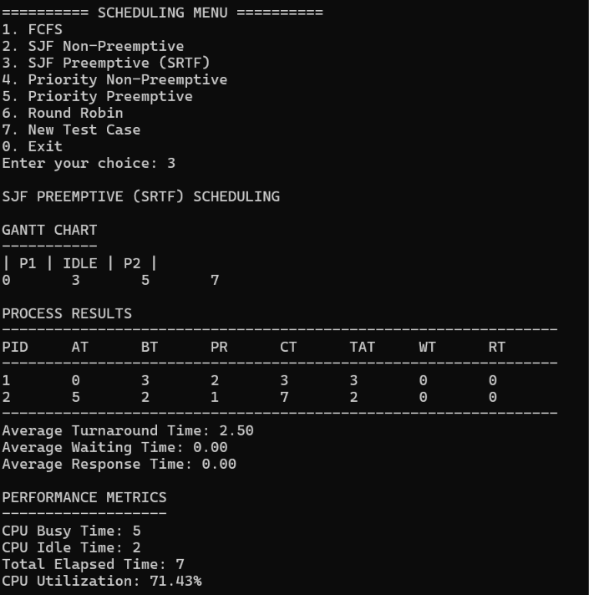

6.4 Priority Non-Preemptive Scheduling
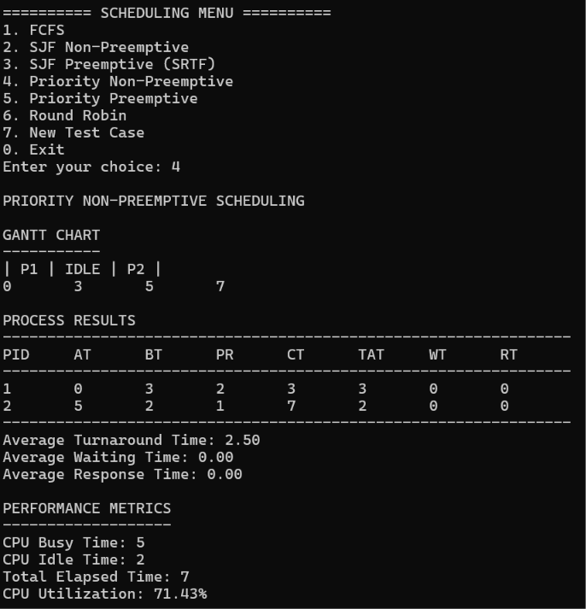

6.5 Priority Preemptive Scheduling
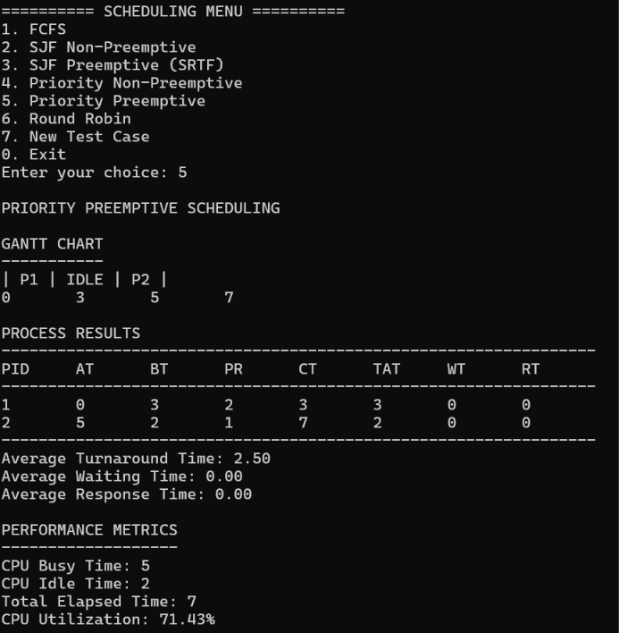

6.6 Round Robin Scheduling
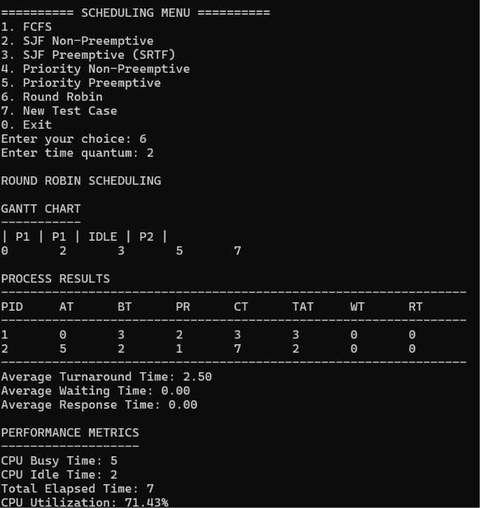

6.7 Compare All Algorithms
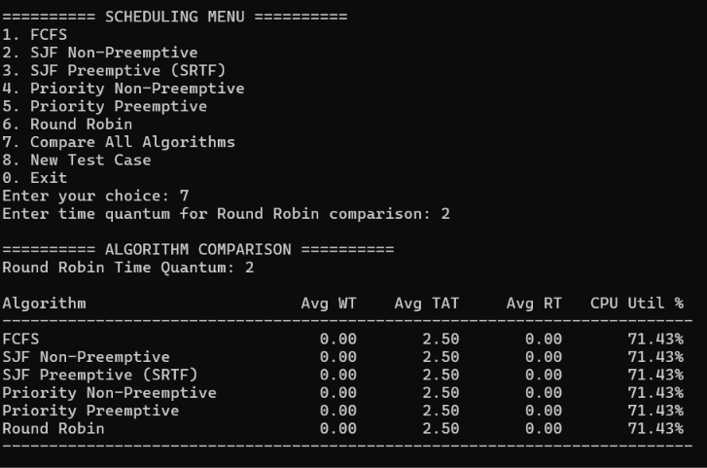

7. Performance Comparison
The performance of the six CPU scheduling algorithms was evaluated using three different test cases. The comparison is based on average waiting time (Avg WT), average turnaround time (Avg TAT), average response time (Avg RT), and CPU utilization. These metrics help identify how efficiently each algorithm schedules processes and utilizes CPU resources. A Round Robin time quantum of 2 was used for all three test cases.
7.1 Test Case
Algorithm | Avg WT | Avg TAT | Avg RT | CPU Utilization
FCFS | 4.33 | 7.33 | 4.33 | 100.00%
SJF Non-Preemptive | 1.67 | 4.67 | 1.67 | 100.00%
SJF Preemptive (SRTF) | 1.67 | 4.67 | 1.67 | 100.00%
Priority Non-Preemptive | 3.67 | 6.67 | 3.67 | 100.00%
Priority Preemptive | 3.67 | 6.67 | 3.67 | 100.00%
Round Robin | 4.33 | 7.33 | 2.00 | 100.00%

7.2 Test Case 2
Algorithm | Avg WT | Avg TAT | Avg RT | CPU Utilization
FCFS | 1.67 | 4.67 | 1.67 | 100.00%
SJF Non-Preemptive | 1.33 | 4.33 | 1.33 | 100.00%
SJF Preemptive (SRTF) | 1.33 | 4.33 | 1.33 | 100.00%
Priority Non-Preemptive | 1.67 | 4.67 | 1.67 | 100.00%
Priority Preemptive | 2.00 | 5.00 | 1.00 | 100.00%
Round Robin | 2.67 | 5.67 | 0.67 | 100.00%

7.3 Test Case 3
Algorithm | Avg WT | Avg TAT | Avg RT | CPU Utilization
FCFS | 0.00 | 2.50 | 0.00 | 71.43%
SJF Non-Preemptive | 0.00 | 2.50 | 0.00 | 71.43%
SJF Preemptive (SRTF) | 0.00 | 2.50 | 0.00 | 71.43%
Priority Non-Preemptive | 0.00 | 2.50 | 0.00 | 71.43%
Priority Preemptive | 0.00 | 2.50 | 0.00 | 71.43
Round Robin | 0.00 | 2.50 | 0.00 | 71.43

8. Performance Analysis
1. Comparison of Average Waiting Time
Average waiting time indicates how long processes remain in the ready queue before receiving CPU time. In Test Case 1, SJF Non-Preemptive and SJF Preemptive (SRTF) achieved the lowest average waiting time of 1.67 time units. In Test Case 2, both SJF algorithms again recorded the lowest value, at 1.33 time units. In Test Case 3, all six algorithms recorded an average waiting time of 0.00. These results show that SJF can reduce waiting time when shorter processes are scheduled efficiently, although performance depends on process arrival and burst times.
2. Comparison of Average Turnaround Time
Average turnaround time represents the total time taken by a process from arrival until completion. In Test Case 1, both SJF algorithms achieved the lowest average turnaround time of 4.67 time units. In Test Case 2, SJF Non-Preemptive and SJF Preemptive achieved the lowest value of 4.33 time units. In Test Case 3, all algorithms recorded an average turnaround time of 2.50 time units. The results indicate that scheduling shorter jobs earlier can reduce the total time processes spend in the system for some workloads.
3. Comparison of Average Response Time
Average response time measures the time between a process's arrival and its first allocation of the CPU. In Test Case 1, SJF Non-Preemptive and SJF Preemptive recorded the lowest average response time of 1.67 time units, while Round Robin recorded 2.00 time units. In Test Case 2, Round Robin achieved the lowest value of 0.67 time units, followed by Priority Preemptive at 1.00 time unit. In Test Case 3, all algorithms recorded an average response time of 0.00. This comparison demonstrates that an algorithm with a higher waiting time can still provide a quick initial response, depending on the order in which processes first receive CPU time.
4. Analysis of CPU Utilization
CPU utilization indicates the percentage of elapsed time during which the CPU performs process execution. In Test Cases 1 and 2, every algorithm achieved 100.00% CPU utilization, indicating continuous CPU execution during the measured interval. In Test Case 3, all algorithms recorded 71.43% CPU utilization. The lower value is associated with the idle interval before a process arrives. Since the utilization is identical across algorithms within each test case, the arrival times and overall workload have a significant effect on this metric in these examples.
5. Comparison of Preemptive and Non-Preemptive Scheduling
Non-preemptive algorithms allow a process to continue until it finishes its CPU burst, while preemptive algorithms can interrupt a running process when scheduling conditions require it. In Test Case 1, the two SJF algorithms produced identical average waiting, turnaround, and response times. The two priority algorithms also produced identical values. In Test Case 2, Priority Preemptive recorded an average response time of 1.00 time unit, compared with 1.67 for Priority Non-Preemptive, but its average waiting and turnaround times were higher. This illustrates that preemption can improve one performance measure without necessarily improving every measure.
6. Effect of Round Robin Scheduling and Time Quantum
Round Robin allocates CPU time to each ready process for a fixed time quantum before moving to another process when necessary. A time quantum of 2 was used in all three test cases. In Test Case 1, Round Robin recorded an average response time of 2.00 time units, while its average waiting time was 4.33 and average turnaround time was 7.33. In Test Case 2, it achieved the lowest average response time of 0.67 time units, but recorded the highest average waiting time of 2.67 and average turnaround time of 5.67 among the six algorithms. In Test Case 3, all algorithms recorded identical metrics. These results show that Round Robin can provide early CPU access to processes, while its overall performance depends on the workload and selected time quantum.

9. Conclusion
The CPU Scheduling Simulator was successfully developed to demonstrate and compare six CPU scheduling algorithms: First Come First Serve (FCFS), Shortest Job First (SJF) Non-Preemptive, Shortest Job First Preemptive (SRTF), Priority Non-Preemptive, Priority Preemptive, and Round Robin. The project provides a practical way to understand how operating systems select processes for CPU execution under different scheduling policies.
The simulator accepts process details such as process ID, arrival time, burst time, and priority. Based on these inputs, it executes the selected scheduling algorithm and calculates important performance metrics, including waiting time, turnaround time, response time, and CPU utilization. Gantt charts are also generated to show the order and duration of process execution, making the scheduling behaviour easier to understand.
Three test cases were used to evaluate the implemented algorithms under different process conditions. The results showed that no single algorithm produced the best value for every performance metric in every test case. The SJF algorithms recorded lower average waiting and turnaround times in Test Cases 1 and 2, while Round Robin provided the lowest average response time in Test Case 2. In Test Case 3, all algorithms produced the same reported metrics, demonstrating that different scheduling policies can yield identical results for certain workloads.
The performance comparison feature makes it possible to examine all six algorithms using the same process inputs. This helps users understand the differences between preemptive and non-preemptive scheduling, the importance of process arrival and burst times, and the influence of the Round Robin time quantum. The CPU utilization results also demonstrate how idle time caused by process arrival patterns can affect overall CPU usage.
Overall, this project strengthened the understanding of CPU scheduling concepts and demonstrated their implementation using the C programming language in a Linux environment. It also provided practical experience in process handling, algorithm implementation, metric calculation, Gantt chart generation, and performance evaluation. The simulator can be extended in the future with additional scheduling algorithms, graphical visualization, and automated test-case generation to support further experimentation and learning.

